**MATH1019 LINEAR ALGEBRA AND STATISTICS FOR ENGINEERS**

**Lab Test - A**

Semester 2, 2020

Marks: /23

**Name:** Tanaka Chitete

**Student ID:** 20169321

**Instructions**: Download the “Lab_Quiz_Template.docx” Word document and save it to your computer as *Your Name Your ID*, for example: *Joe Smith 2456892.docx*. Write your lab test solutions in this Word template document, and save the file regularly. **All questions require you to copy the commands/output from *R/RStudio* and paste it into this document**. Copying and pasting only the solution is not sufficient, all *R* commands used in making your calculations must be included in your document to obtain full marks. Once you have completed the test, you must submit two documents:

* Your final Word document, with the commands and solutions, is to be **submitted via Blackboard** using the View/Complete link found under Lab Assessment Submission. This will submit the assessment to Turnitin for similarity checking and marking by the tutors. The **Submission Title** should be in the form of *Your Name Your ID* (so for example, *Joe Smith 2456892*). After submitting the file to Turnitin you should receive a receipt to say it has been submitted correctly. To double-check this step has been completed, go back into the View/Complete link under Lab Assessment Submission and check that your submission is there and that you have submitted the correct file.
* The physical test paper, to be completed with your name and student ID is to be **submitted in person** to your tutor before you leave the room.

**Question 1**

Question 1a

> data("cars")

> scatter.smooth(cars$speed, cars$dist, main="Speed vs Distance", xlab="Speed", ylab="Distance")

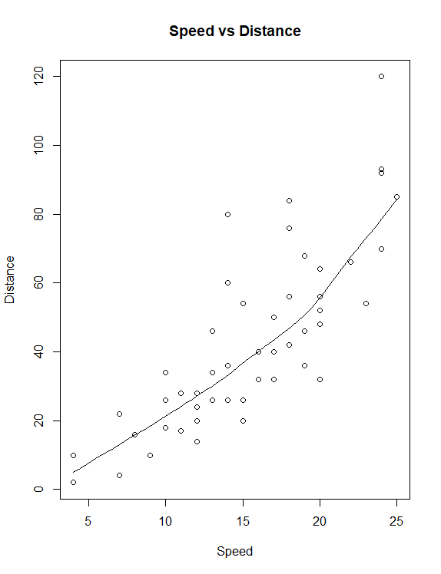

Question 1b

It is positive because as Speed increases, distance increases as well. This can be observed from the line of best fit.

Question 1c

> stem(cars$speed, scale=1)

The decimal point is at the |

4 | 00

6 | 00

8 | 00

10 | 00000

12 | 00000000

14 | 0000000

16 | 00000

18 | 0000000

20 | 00000

22 | 00

24 | 00000

Question 1d

> fivenum(cars$speed)

[1] 4 12 15 19 25

The numbers correspond to minimum, Q1, median, Q3 and maximum

Question 1e

> IQR(cars$speed)

[1] 7

Question 1f

> boxplot(cars$speed, main="cars speed Attribute", ylab="Speed")

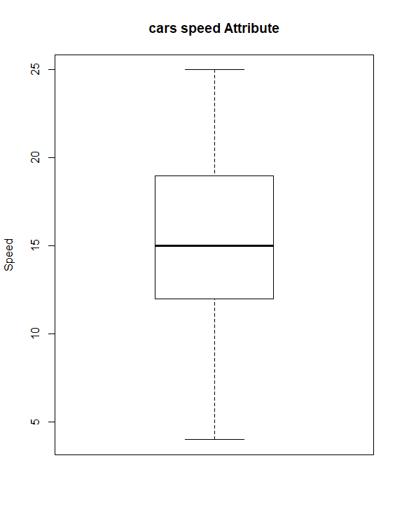

There are no outliers

Question 1g

> mean(cars$speed)

[1] 15.4

> sd(cars$speed)

[1] 5.287644

Question 1h

> x_bar <- mean(cars$speed)

> s <- 7 * sd(cars$speed)

> z <- qnorm(0.90)

> n <- length(cars$speed)

> lower_bound <- x_bar - z * (s / sqrt(n))

> upper_bound <- x_bar + z * (s / sqrt(n))

> lower_bound

[1] 8.691717

> upper_bound

[1] 22.10828

Therefore, the 90% CI for the population mean is (8.691717, 22.10828)

**Question 2**

Question 2a

> pbinom(50, 210, 0.27) - pbinom(45, 210, 0.27)

[1] 0.1292852

Therefore, P(45 ≤ X ≤ 50) = 0.1292852

Question 2b

> qbinom(0.7, 210, 0.27)

[1] 60

Therefore, the integer k such that P(0 ≤ X ≤ k) is approximately 0.7 is 60

**Question 3**

Question 3a

> outcomes <- seq(from=-4, to=4, by=1)

> hist(replicate(500, mean(sample(outcomes, 200, replace=TRUE))), main="", xlab="Win/Loss Amount ($)")

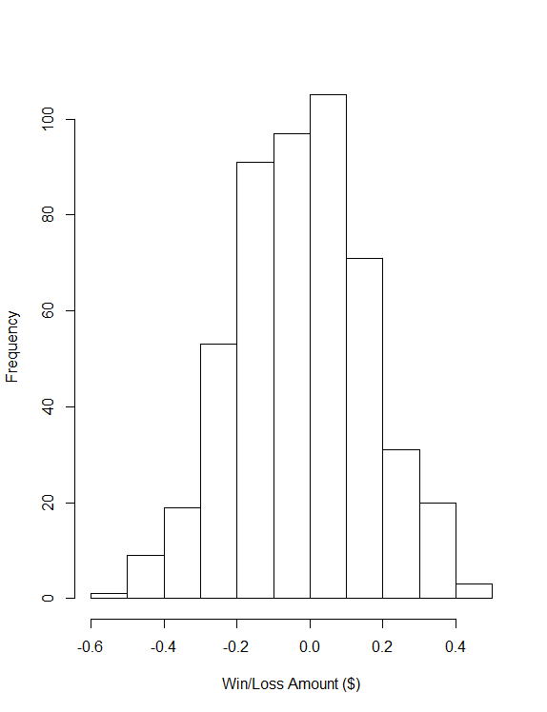

Question 3b

The histogram is roughly symmetric and approximately normal